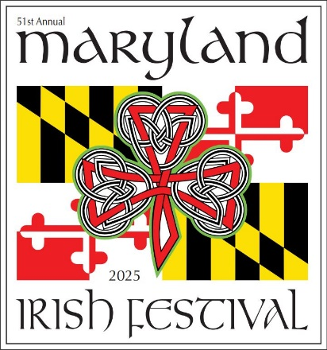

MARYLAND IRISH FESTIVAL
ANNUAL PHOTO RELEASE FORM

I, the undersigned, ______________________________ own the rights in the ___________________________ (the "Work") that is depicted in a photograph or photographs taken by ________________________. I give the MARYLAND IRISH FESTIVAL permission to use my Work in his or her entry to the Photo Contest. I give the MARYLAND IRISH FESTIVAL license to publicly display, distribute, reproduce, and create derivative works of that entry, including the depiction of my photograph, in whole or in part, in any media now existing or later developed, for any purpose, including, but not limited to, advertising and promoting its website. I understand that I shall not receive any compensation for these uses and that the MARYLAND IRISH FESTIVAL is under no obligation to use the entry in any way. I waive any claim or right of action arising out of the uses authorized in this release.

Print Name: _________________________________________________

Art Work’s Name: _____________________________________________

Address: ____________________________________________________

E-mail: ______________________________________________________

Telephone: ____________________________

Signature: _____________________________
Date: _________________________________

